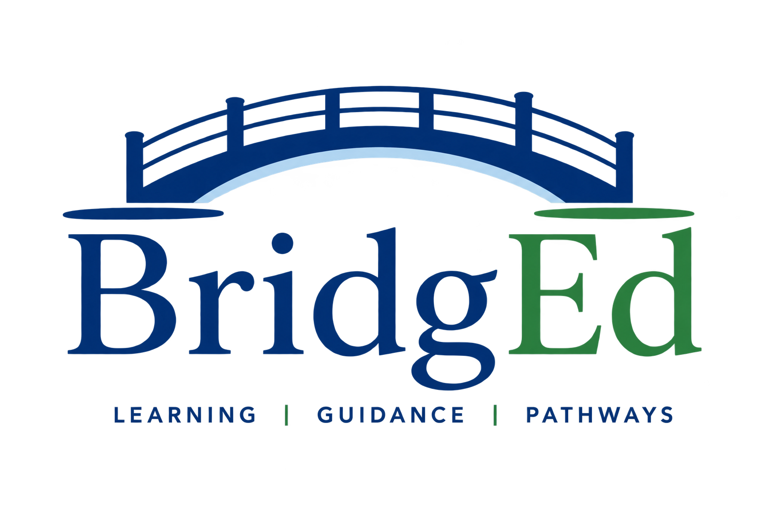

Child Safeguarding Statement
  - For online educational assessment, tutoring and pathway guidance
These policies apply to BridgEd Learning’s online work with students aged approximately 14 years and over. Parents/carers do not need to attend routine sessions, but must know when sessions occur, provide current emergency details and remain reasonably contactable.

1. Child Protection

Our commitment
BridgEd Learning is committed to providing an online environment in which children and young people are safe, respected and able to raise concerns. The safety and best interests of the student take priority over convenience or business interests.

Professional boundaries and online safety
- Sessions use an agreed platform. Personal social-media accounts and disappearing messages are not used.
- The parent/carer knows the session time and remains reasonably contactable.
- A student should use a suitable learning space.
- Routine sessions are not recorded. The family must not record, photograph, stream or allow another person to observe a session without prior agreement.
- Communication remains professional, age-appropriate and connected to learning, safety or administration. Significant matters are communicated to the parent/carer.
- BridgEd does not engage in inappropriate conduct or private personal relationships with students.
- A session may be paused or ended if privacy, behaviour, participation or safety becomes a concern.

If a student discloses harm or a concern arises
BridgEd will comply with obligations applying to a Western Australian registered teacher, including mandatory reporting requirements.

Complaints and student voice
A student or parent/carer may raise a concern verbally or in writing. Concerns will be taken seriously, handled as privately as possible and will not disadvantage a student. A matter involving immediate danger, suspected abuse or serious misconduct will be referred to the appropriate authority rather than handled only as customer feedback.

2. Privacy Policy

The information we collect
- student and parent/carer names, contact details, date of birth and emergency information;
- education history, learning goals, relevant adjustments and information supplied by the family;
- literacy and numeracy assessment responses, results and reports;
- Learning and Engagement Profile responses, work samples and progress information;
- booking, payment, communication, session, incident and complaint records; and
- information received from a school or professional with consent, or where collection is otherwise authorised.

Why we collect and use it
Information is used to decide whether BridgEd is suitable, administer and interpret educational assessments, plan and provide tutoring or guidance, communicate with families, arrange school liaison, manage safety, administer payments, respond to concerns and meet legal or insurance obligations.

Assessment and online platforms
BridgEd uses third-party assessment and video-meeting platforms. Only information reasonably needed for the service will be stored. Routine online sessions are not recorded.

Consent and sensitive information
Information will be collected directly from the parent/carer or student. Consent will be obtained before collecting sensitive information where required. Families should provide only information reasonably relevant to learning, participation or safety. BridgEd’s Learning and Engagement Profile is an educational tool, not a psychological or medical assessment.

Storage and security
- Electronic records are securely stored.
- Devices are locked, updated and not shared with unauthorised people.
- Access is limited to people who need the information to provide or administer the service.
- Information is retained only while reasonably needed for service, safety, legal, tax or insurance purposes, then securely deleted or destroyed.
- A suspected data breach will be contained, assessed and communicated where required or reasonably necessary to reduce harm.

When information may be shared
Information may be shared with consent, only when necessary. Information may be disclosed without consent when reasonably necessary to respond to an immediate safety concern or child-protection obligation.

Access, correction and privacy concerns
Parents/carers should have a reasonable expectation that information will be shared when necessary. Any privacy concerns relating to family members or custody arrangements should be communicated to BridgEd.

